**How to Implement Web Service Calls in IBM BPM?**

IBM BPM will supports web service calls, before going to do how to achieve this we should know how the webservice is exposed.

We have two types of webservice calls one Rest based, SOAP based.

In IBM BPM we have an "***Integration Service***" where we can implement web service calls, in Integration service system we have a component called Web Service component by using that we can do webservice which is exposed as a WSDL(SOAP Service).

We can consume SOAP services in two ways:

1) Web Service Integration - Component

2) Web service Via SOAP - Integration Service

Let's take a look on both types with an example:

**1) Web Service Integration - Component**

This is a component in "***Integration Service***" where you need to copy paste the WSDL url, for this we have different type of buttons like Browse, view, Discover, Generate Types.

After dropping component in canvas you need to "**provide Inline configuration**" in implementation tab, paste the WSDL URL in wsdl Url section and click on Discover button, this will discover the supported methods by wsdl

Configuration can be see n in below pic: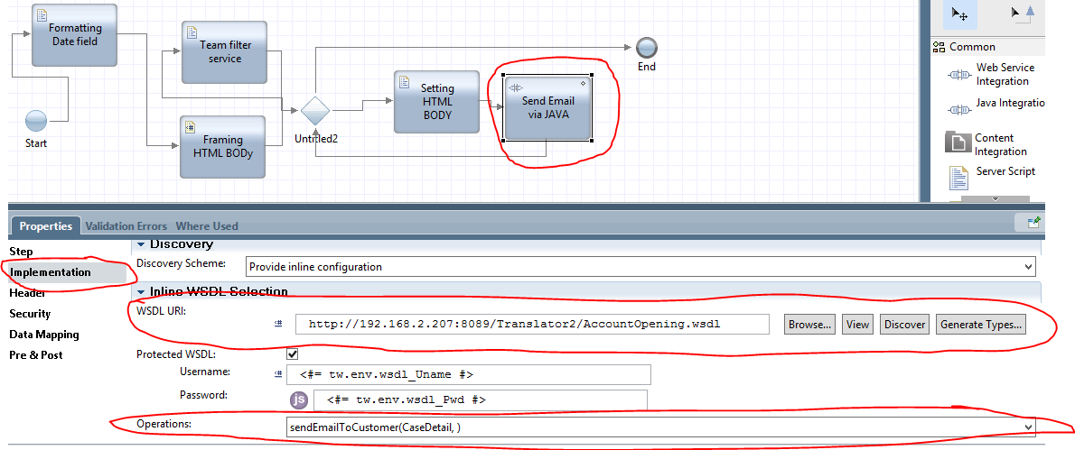

The above screen shot will give you details of how to invoke secured wsdl, after clicking on discovery in the operation drop down we will see what are the supported services, we will select based on the requirement. Once this configuration is done we will setup DataMapping. We need to map input and output variables.

**2) Web service Via SOAP - Integration Service**

This is somewhat difference when comes to implementation the implementation looks like

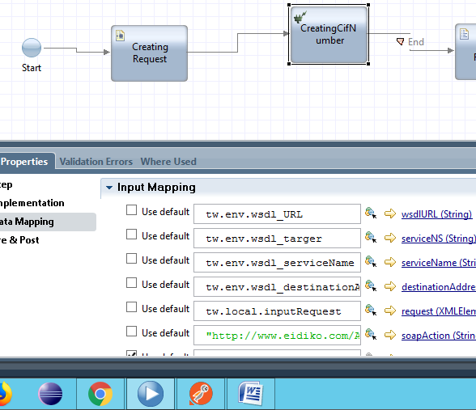

for this we have to drop the Nested Service Component, then select Call Webservice Via Soap then give the details as in above image

For more details check for call webservice via soap in IBM Knowledge Center.

<https://www.ibm.com/support/knowledgecenter/SSFTN5_8.5.7/com.ibm.wbpm.wle.editor.doc/topics/t_soapconncall.html>

**Implementing Rest Service:**

IBM BPM will also support Rest service functionalities, there are different methods like Get, Post, Put, Update, Delete methods. We can do all this action using JAVAScript (or) Jquery Ajax if we now how to write JAVAScript or JQuery AJAX services, Other than this IBM BPM hass default component called "***Read From HTTP***" which is an integration service which is a system data toolkit. Whenever you are doing Rest service(Third Party Service),There you will get SSLHandshake Error you need to add SSL certificates to WAS(Web Sphere Application Server).

How to add? Where to add SSL certificate to make Successful Rest Call?

1) Open WAS(WebSphere Application Server <https://ibpm85:9043/ibm/console>) in left side selection panel shows in below image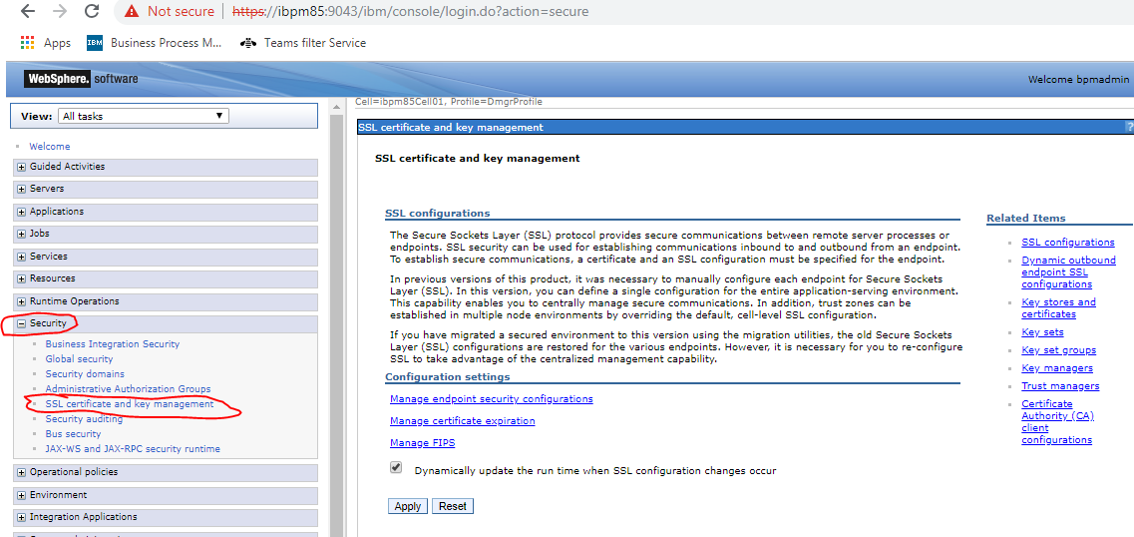

Expand Security tab **Security** > **SSL Certificate and key management** > **Key stores and certificates.**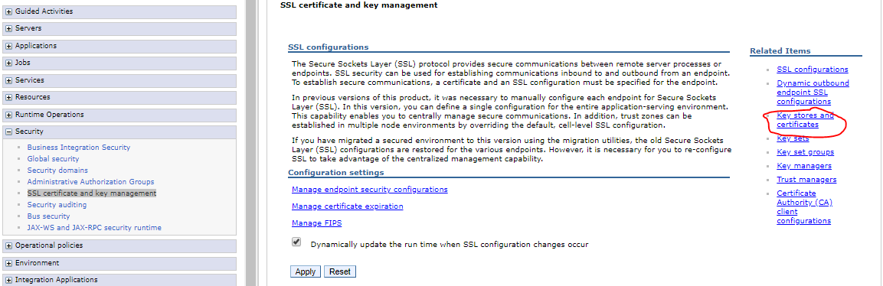

Select **"CellDefaultTrustStore"**

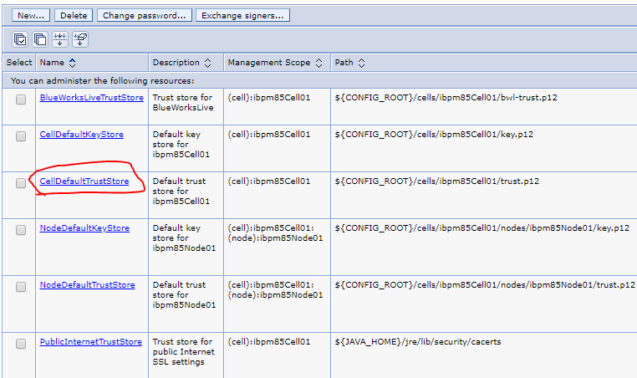

It will Open a page then select "Signer Certificate".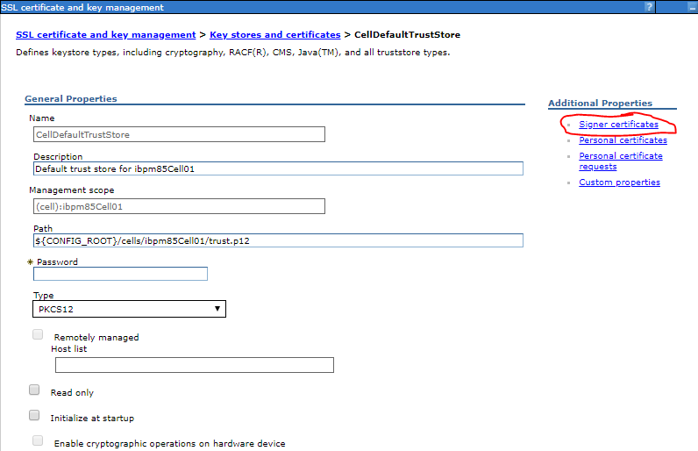

Once you clicked you will see following page, then select "Retrieve from port" button. Then enter host, prt

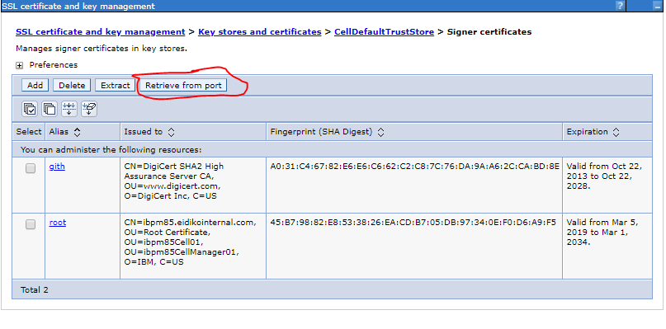Then it takes to a page where we need to enter Host,Port number alias name, after giving all values click on retrieve signer information button so that shows the signer information based on your given value, then select Apply button, after that select synchronous check box and click on Save. Now certificate added to our environment

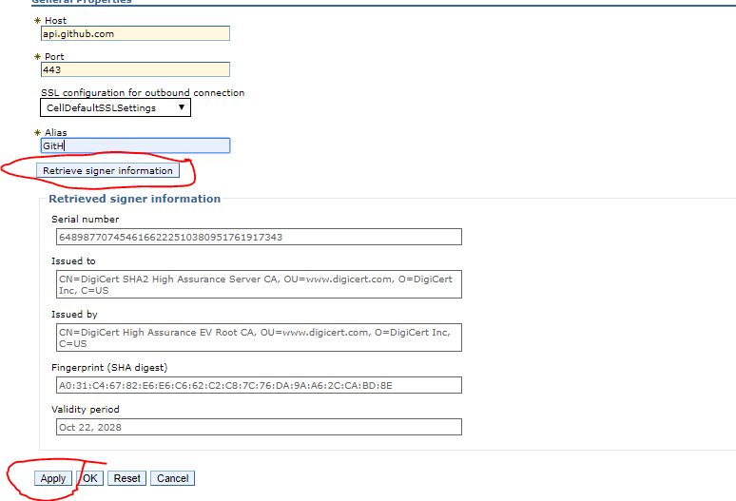

For more info follow below link:

<https://www.ibm.com/support/knowledgecenter/en/SSYGQH_6.0.0/admin/install/t_exchange_keys_network.html>

But there is no specific service to do a post call from IBM BPM, to achieve this we need to download KolbanTK.jar form the below link

<https://git.ng.bluemix.net/harishvarma8055/Bpm_restcalls_JAR_file>

or we need to add kolban toolkit to our pd.

After downloading add jar file to BPM as a server file. Once you added that jar file create an integration service where you need drop an JAVA integration component in canvas where you want to invoke rest call. After dropping the component we need to add kolban jar packages. Implemented service looks like below image.

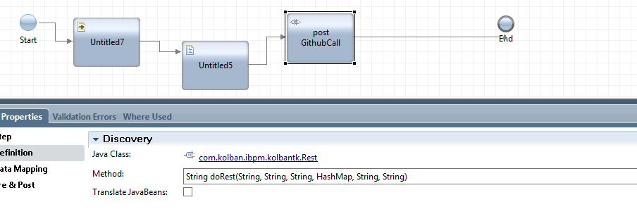

Select Method as String doRest pass the values in DataMapping section. It looks like below image.

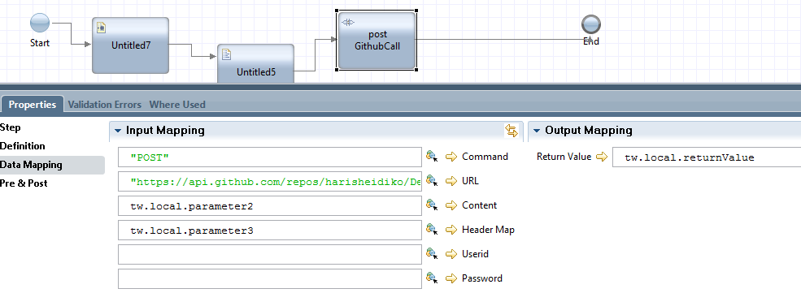

The parameter2 will be set in scriptlet tag. It will be like

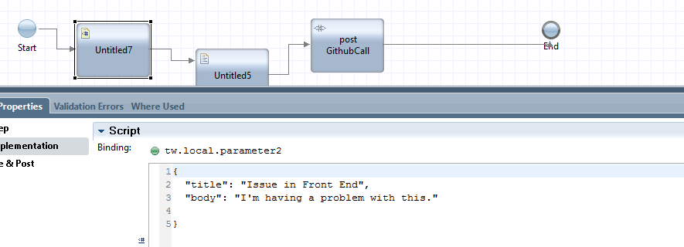

The header values will be set in script tag that looks like in below image.

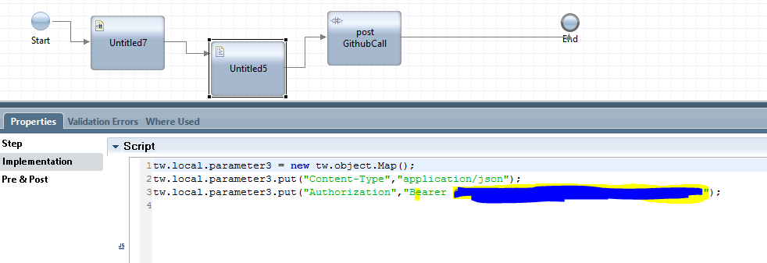

Note: This will work after doing SSL